SE-Assignment-5. Gontse Brooklyn Otto

Installing VS Code on Windows 11

Prerequisites:

Windows 11 operating system (32-bit or 64-bit)

Internet connection for downloading the installer

Steps:

Download:

Visit the official Visual Studio Code download page: <https://code.visualstudio.com/download>

Click the "Download for Windows" button. Choose the installer version that matches your system architecture (32-bit or 64-bit).

Run the Installer:

Double-click the downloaded installer file (typically named VSCodeSetup-{version}.exe).

Follow the on-screen instructions. You can choose the installation location and optionally add VS Code to your system PATH for easier access from any directory in your command prompt/terminal.

Launch VS Code:

Once the installation is complete, you can launch VS Code from the Start menu or by double-clicking the desktop shortcut (if created during installation).

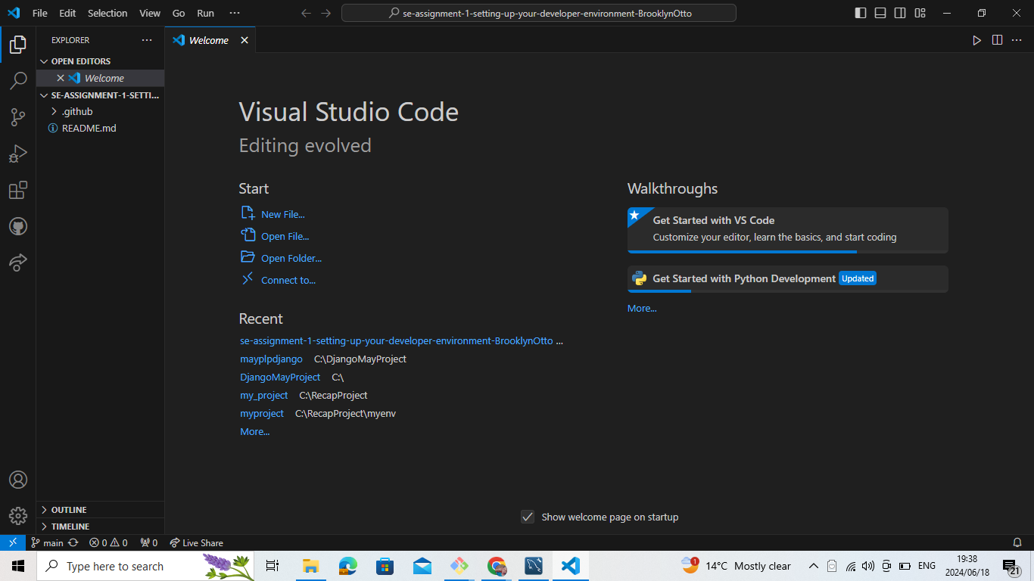

First-time Setup:

Initial Configurations:

Themes: Explore the built-in themes (go to File > Preferences > Settings or Code > Preferences > Settings on macOS) and choose one that suits your preference (e.g., Dark+ Default for a dark theme).

Extensions: Install essential extensions for your development needs (see below).

Settings: You can adjust font size and some keyboard shortcuts in the Settings menu.

Essential Extensions (for Web Development):

HTML Language Tools: Provides syntax highlighting, IntelliSense code completion, and other features for HTML development.

ESLint: Linter for JavaScript that helps identify and fix errors in your code.

Live Server: Launches a local development server to preview your web pages in a browser.

There are many other extensions available, explore the VS Code Marketplace for more options!

User Interface Overview:

Main Components:

Activity Bar: Located on the left by default, it provides quick access to different VS Code features like the integrated terminal, extensions, and debugging tools.

Side Bar: Contains file explorer, search functionality, and project management tools (if using extensions).

Editor Group: The central area where you write and edit your code. You can have multiple editors open in tabs.

Status Bar: Located at the bottom, it displays information like current line number, indentation mode, and Git integration status (if using Git).

Command Palette

The Command Palette is a powerful tool that lets you access all VS Code features and settings with a keyboard shortcut (Ctrl+Shift+P on Windows/Linux, Cmd+Shift+P on macOS). Type your desired action and select it from the list to perform it quickly.

Examples:

Open a new file: "New File"

Search for a specific setting: "Preferences: Configure Settings"

Install an extension: "Extensions: Install Extension"

Extensions in VS Code

Extensions are add-ons that extend VS Code's functionality for various programming languages, frameworks, and development tasks.

Finding and Installing Extensions:

Open the Extensions view (Ctrl+Shift+X on Windows/Linux, Cmd+Shift+X on macOS).

Browse the featured extensions or search for specific ones.

Click the "Install" button for the desired extension.

Integrated Terminal

The integrated terminal provides a command-line environment within VS Code, allowing you to run shell commands, build projects, and use Git directly from your code editor.

Advantages:

Convenience: No need to switch between VS Code and a separate terminal window.

Integration: Execute tasks related to your project directly from the editor.

File and Folder Management

Creating and Opening Files:

Go to File > New File or use the keyboard shortcut (Ctrl+N on Windows/Linux, Cmd+N on macOS) to create a new file.

Use File > Open File or Ctrl+O (Cmd+O on macOS) to open existing files.

Navigation:

The Side Bar provides a file explorer for browsing project folders and files.

Use the "Go to File" functionality (Ctrl+T on Windows/Linux, Cmd+T on macOS) to quickly jump to specific files within your project.

Settings and Preferences

You can find settings in the "Settings" menu (File > Preferences > Settings or Code > Preferences > Settings on macOS). Search for specific settings or browse through categories to customize VS Code's behavior.

Examples:

Change theme: Search for "Theme" and select your preferred theme.

Adjust font size: Search for "Font Size" and set your desired size.

Modify keybindings: Search for "Keyboard Shortcuts" and edit existing bindings or create new ones.